Key points for discussion with Environment Select Committee
Background
Bill proposes to include the following to enable regulation making powers that:
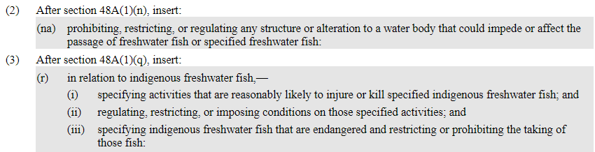
Concerns about the proposed regulations:
- Potential impact on existing lawfully established in-stream structures and activities
- IEGA members have a number of existing lawfully established in-stream structures and activities that are critical to our electricity generation.
  - It is unreasonable to impose additional regulation-making powers in respect of existing structures and activities which were designed to be compliant with the regulatory regime in place at the time of construction
  - It may also be physically, technically, economically or commercially impractical to retrospectively change such structures.
  - It would be intolerable if the new regulation making powers prohibited or restricted these activities.
Recommendation - any powers conferred by the proposed amendment should specifically exclude existing hydroelectric generating plant structures and activities (applying only to new structures and activities where there is the opportunity to design and build the structure to take into account regulatory requirements applying at that time)

- Interaction between the Bill and existing resource management requirements
- Existing hydroelectric structures and activities are subject to detailed operational controls under existing resource consents.
  - It may be legally impossible to comply with new regulations if the regulations are inconsistent with existing resource consents.

- The effects on indigenous fish are routinely considered at the time of re-consenting under the RMA.
  - Considering the effects on indigenous fish under the RMA continues to be appropriate for existing structures and activities.

- It is unclear whether applying for a new resource consent on expiry of an existing resource consent would be classified as a ‘new’ activity and therefore become subject to any restrictions imposed by the new regulations.
  - Clarity is important on this issue
Recommendation - at a minimum, the Bill needs to be amended to clarify that the application for a resource consent for an existing lawfully established structure would not trigger the regulations made under this Bill/Act. (This would be consistent with the Freshwater Fisheries Regulations 1983.)
(Mercury’s submission refers to the existing Freshwater Fisheries Regulations 1983. These regulations, administered by the Department of Conservation, recognise the impracticality of applying new regulations to existing structures or activities. Regulation 43 provides an exclusion from requirements to include a fish pass or fish screen for long standing dam and diversion structures subject to a water right prior to 1 January 1984. These regulations also allow for investors in any dam or diversion structure to seek approval for or a dispensation from the requirements of the regulations to build a ‘fish facility’. )

- Duplicate processes
- There is the potential that new activities are subject to a duplicate process - both the resource consent process under the RMA and any requirements or restrictions imposed under the new regulations.

- This would both unnecessary and undesirable.

- The resource consent application process already requires local authorities to consider actual or potential effects on the environment, which includes any relevant effects on freshwater indigenous fish.

- The Dept of Conservation has the right to submit during resource consent application processes – and does.
Recommendation – the Bill be amended so that where the effects on freshwater indigenous fish have been considered through the resource consent process for new or existing structures, this removes any requirement for these activities to be subject to the new regulations.
The smaller scale of our plant means that resource consent and other regulatory processes are a disproportionate impost on our members, relative to the utility-scale hydroelectric generators.

- Concerns about consultation
- Bill does not include any requirement for the Department to consult as it develops regulations.

- Also the Department of Conservation did not consult with stakeholders on the content of this Bill. If the IEGA had been aware of the development of this Bill we would have engaged constructively with officials - sharing useful practical information and hopefully avoiding unintended consequences

